Mathematics
An Etoys Number Slate: Multiply and Divide
Second-Third Grade Levels

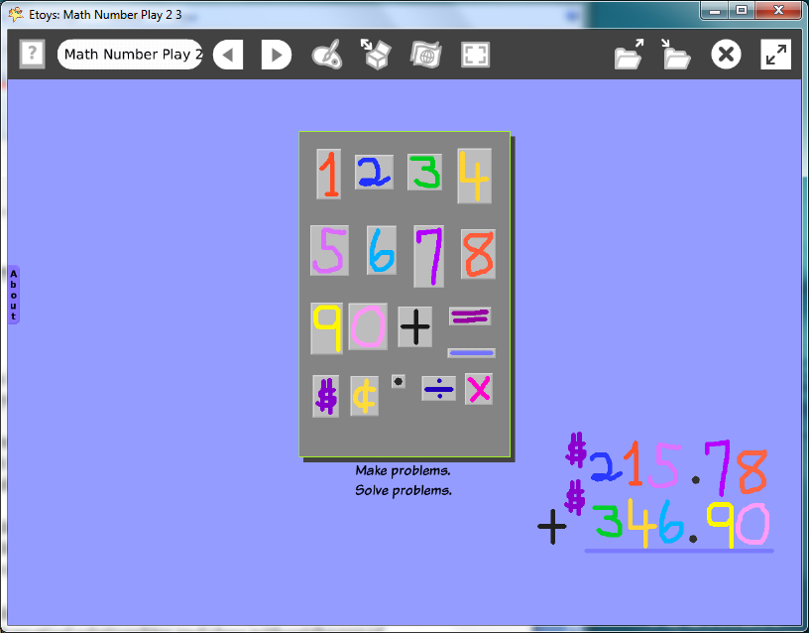

Introduction: | This lesson suggests many ways for students to use the Etoys number slate to experiment with numbers.  Patterns and sequences are easy to construct and change with this project. Students can play with and think about numbers, their order and patterns.  Students add the math symbols for multiply and divide and for dollars and cents to the number slate they made in a previous project.
Topic: | Students use the set of numbers to explore and develop mathematical relationships and ideas without the use of pencil and paper.
Subject: | Mathematics
Time: | 30 Minutes
Description: | The number slate is a limitless supply of numbers for counting, sequencing, and creating patterns.
Vocabulary: | add, subtract, equals, multiply, divide, dollars, cents, decimal, counting, number names, zero, nothing, pattern, duplicate, copy, set, sequence, above, below, beside, before, left, right, upper, lower, edge, near, up, down, between, almost, add, subtract, equals, exactly
Evaluation Criteria: | Add and subtract single and two digit numbers.  Multiply single digit numbers  Use dollar and cents signs  Includes a decimal in their working set  Knows odd and even numbers  Knows concepts: more than, less than, the same as  Knows how to Find and Publish Etoys project.  Knows how to use a playfield like a slate or sheet of paper.
Teacher Information:  Etoys Quick Guides: Click the question mark in  Etoys to open the set of tutorials about basic tools and techniques. | Etoys Quick Guides: Click the question mark in  Etoys to open the set of tutorials about basic tools and techniques.  Use Etoys Quick Guides if the lesson mentions unfamiliar tools or techniques. Give students time to read them too.
Goals: | Students use the slates of numbers to play with and to explore mathematical ideas. The lesson suggestions can be a source of ideas for small groups or independent experiments with numbers.
Lesson 1:  One lab  Navigator Bar: Keep Find Projects | Students open their previously made number slate and draw the symbols they will use in the math curriculum for Second and Third Grades. New students could use slates from EtoysIllinois.org, or make one. It takes about a half hour to make a slate of numbers.  Remind students to make the new signs small enough to fit on their thumb nail.
Extend Lesson 1 | Use these activities with the whole class or pairs of students. The number slate is a source of beautiful numbers for projects in science, language arts, and social sciences.  Ask how many numbers of each color they have and make a chart on paper in the classroom from that data.  Ask what number comes next in a given sequence. Students could make sequences and pose them as puzzles for nearby students to solve.  Use the set of numbers for experimenting with mathematical concepts, groups, and tens, some may be revealed more easily due to the colors students have chosen.  Practice math facts or to explore word problems, or formulas.  Note:  There are two easy ways to clear the screen of puzzles and problems students no longer want showing on their screen.  Do all the work on a new playfield and click the X to through away it and everything on it.  Shift/drag key a box over the unwanted material then click the X.  Remind students that the tip of the cursor arrow is what does the work, not the stem.
Student Information: | Show students an example screen if an LCP projector is available or use a computer and show examples to small groups.
Standards: | Mathematics  Illinois Performance Standards  Second Grade:  6A, 6B, 6C, 6D Number Work  9A Patterns and Rules, counting by 2’s, 5’s, 10’s  9B Sorting  10B Data Collection  Third Grade:  6A, 8A, 6C, 8C, 10A Visual Patterns, Number Patterns and Counting  Language Arts  Illinois State Goals K-3 Listening  4. A.1a Listen attentively by facing the speaker, making eye contact and paraphrasing what is said.  4. A.1b Ask questions and respond to questions from the teacher and from group members to improve comprehension.  4. A.1c Follow oral instructions accurately.  4. A.1d Use visually oriented and auditory based media  Language Arts  Illinois State Goals K-3 Speaking  4. B.1a Present brief oral reports, using language and vocabulary appropriate to the message and audience (e.g. show and tell)  4. B.1b Participate in discussions around a common topic.  National Educational Technology Standards (NETS)  1. Basic operations and concepts  Students are proficient in the use of technology.  2. Technology productivity tools  Students use technology tools to enhance learning, increase productivity, and promote creativity.  Students use productivity tools to collaborate in constructing technology-enhanced models, prepare publications, and produce other creative works  4. Technology communications tools  Students use a variety of media and formats to communicate information and ideas effectively to  multiple audiences.
Resources: | Etoys Help Quick Guides: Open Etoys and click the question mark in the Navigator Bar to open a set of interactive tutorials that introduce basic tools and techniques.  EtoysIllinois.org for projects, tutorials, and lesson plans  Squeakland.org to download Etoys software
kh
April 9, 2012

